**Installation of Java in Red 8.0 Hat AWS EC2**

**Requirements**

* AWS Account
* Email address
* Provisioned EC2 instance with Red Hat Enterprise Linux AMI
* Putty
* Winscp

STEP-1 First download the JDK tar file for red hat.

STEP-2 Now connect instance using putty

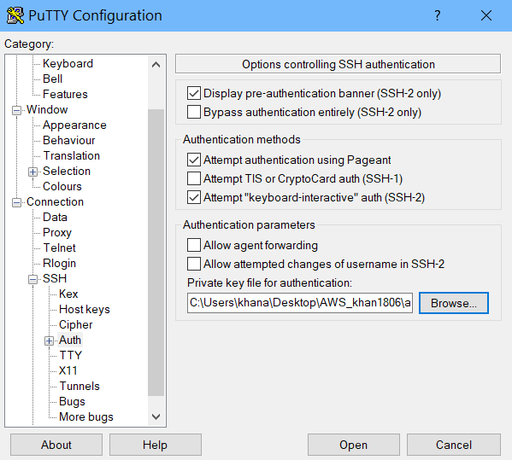

STEP-3 Now connecting Winscp and transfer the JDK tar file to cloud AWS.

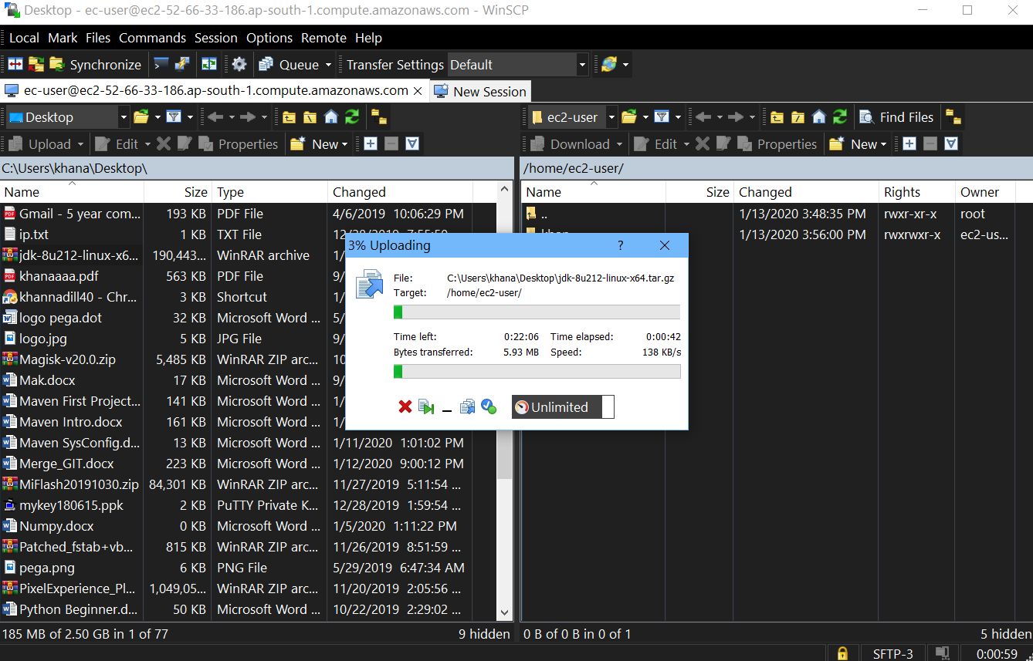

STEP-4 In /home/ec2-user tar file is reflected.

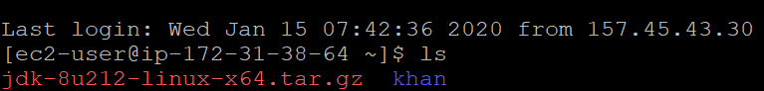

STEP-5 We have to move this to /opt/ that is in root

So run command

sudo cp –r jdk-8u212-linux-x64.tar.gz /opt

This will copy tar file to /opt/ directory

STEP-6 Now unzip it using

tar –xzfv jdk-8u212-linux-x64.tar.gz



STEP-7 Now install jdk in /opt/ by running command

alternatives --install /usr/bin/java java /opt/jdk1.8.0_212/bin/java 2

alternatives --config java

choose 1

alternatives --install /usr/bin/jar jar /opt/jdk1.8.0_212/bin/jar 2

alternatives --install /usr/bin/javac javac /opt/jdk1.8.0_212/bin/javac 2

alternatives --set jar /opt/jdk1.8.0_212/bin/jar

alternatives --set javac /opt/jdk1.8.0_212/bin/javac

STEP-8 Now set env

Open vi /etc/environment and add this lines

export JAVA_HOME=/opt/jdk1.8.0_212

export JRE_HOME=/opt/jdk1.8.0_212/jre

export PATH=$PATH:/opt/jdk1.8.0_212/bin:/opt/jdk1.8.0_212/jre/bin

STEP- 9 Now verify the installation by

Running java –version

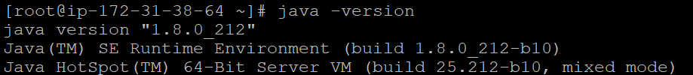

Finally, java installation is done.

**Install apache maven**

**STEP-1** Prerequisites

Java development kit is the primary requirement of Apache Maven. So you need to install Java development kit (JDK) on your system. Make sure you have installed JDK, not JRE.



If you don’t have Java Development Kit installed on your system.

**STEP-2** Install Apache Maven

After verifying java version on your system. Download Apache Maven from its official website or use the following command to download Apache Maven.

Change directory cd /opt/

wget <https://www-eu.apache.org/dist/maven/maven-3/3.6.2/binaries/apache-maven-3.6.2-bin.tar.gz>

Now extract in /opt/maven

Tar –xzf apache-maven-3.6.2-bin.tar.gz maven

**STEP-3** Setup Environment Variables

Now set the environments variables by creating new file /etc/profile.

Vi /etc/profile

And at last line

Export M2_home=/opt/maven

Export PATH=${M2_HOME}/bin:${PATH}

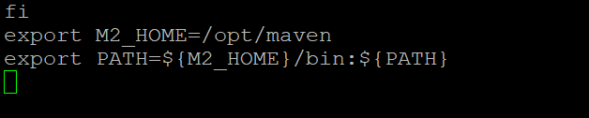

Now load the environment variables in current shell using following command.

Source /etc/profile

**STEP-4** Check Maven Version

mvn –version

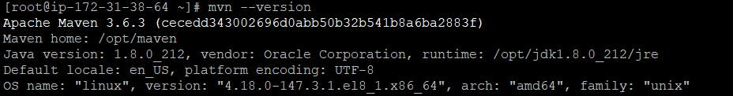

Project in Maven

1. Mvn archetype:generate
2. groupID🡪com.adil
3. archetypeID🡪maven-adil
4. version🡪1.0-SNAPSHOT
5. package🡪adil
6. then confirm by pressing Y
7. cd maven-adil/
8. mvn package
9. java -cp maven-adil-1.0-SNAPSHOT.jar adil.App
10. 